**How to insert table with Data in an Offer Letter using BIRT?**

**Document Configuration**

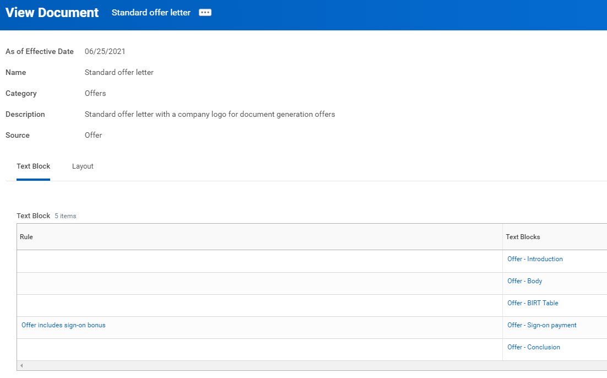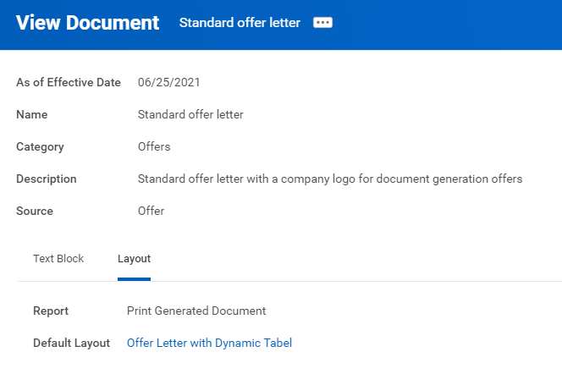

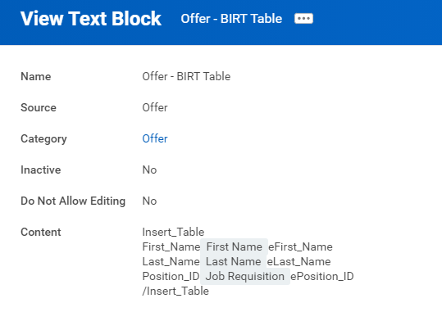

We have added tags before and after the data which we want inserted in a table.

This will help us identify the data on the BIRT.

**Report –** Using the Delivered Report – “Print Generated Document”

**BIRT Design**

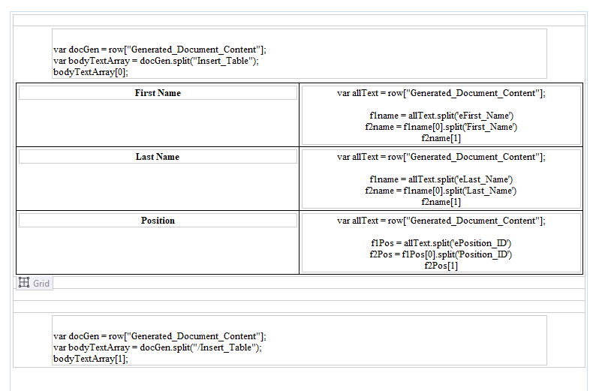

**Code: var** allText = row["Generated_Document_Content"];

f1name = allText.split('eFirst_Name')

f2name = f1name[0].split('First_Name')

f2name[1]

**Sample**

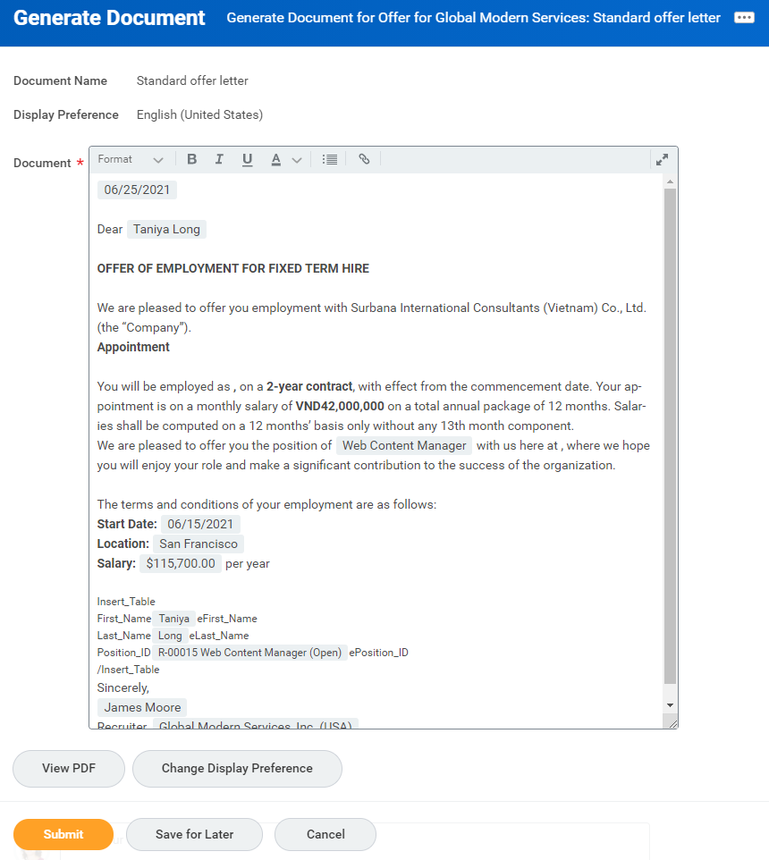

This is the only drawback that the table will not come in the Generate Document step; but we can use the View PDF button to see how it will look in the Generate Document Step.

